Final Project: Applying FreeRTOS and the embedded systems approach to real-life applications

Lab Group 4 - Final Project Proposal - CSE/EE 474

Description
Provide a brief overview of the project. Explain the motivation behind the project, the problem it aims to solve, or the opportunity it seeks to capitalize on. You can use this document as a template for your proposal submission.

The “Explosive Home Security System” is a project designed to keep intruders out of people’s houses or take everything down. Motivated by burglaries in the Seattle area and allowing people to feel safe leaving valuables in their homes, this project aims to address the problem of theft and burglaries. By utilizing sensors, RFID, a keypad, and a phone bluetooth connection with two ESP-32s, the system is designed to allow anyone with the correct RFID and correct keypad PIN to access the home otherwise a ‘bomb’ will explode. The phone is able to use its bluetooth connection to set the security system to home/away to turn it off/on. This application of bluetooth allows for easy access in and out of the house if needed for situations such as just getting the mail or doing some gardening without needing to enter a password/scan an RFID all the time; allowing for a safe but also convenient home life.

Components/Diagram
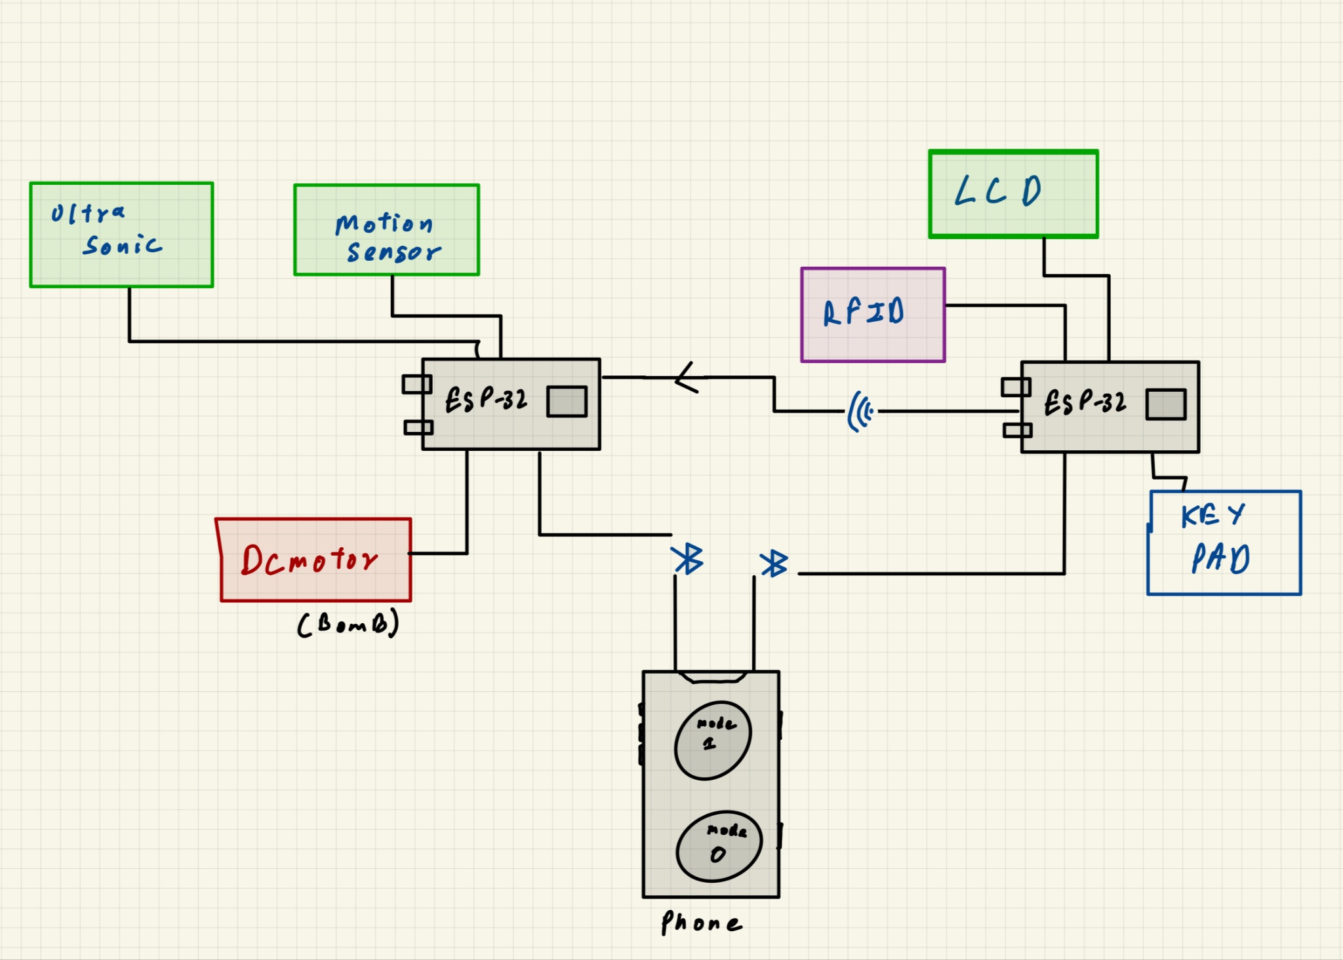

Example:
Smart Plant Monitoring and Watering System

SENSORS
Component | Description | Link(s)
Motion Sensor | Detects Motion Outside the House  And Prompts to enter the password onto the LCD if motion is detected.  If Home Mode is ON, Then its off | https://learn.adafruit.com/pir-passive-infrared-proximity-motion-sensor/overview
Ultra-Sonic Sensor | Detects Motion Inside the House if Home Mode is OFF.  If Home Mode is ON, Then its off | https://web.eece.maine.edu/~zhu/book/lab/HC-SR04%20User%20Manual.pdf

MICROCONTROLLER
Component | Description | Link(s)
ESP-32 S3 Dev | One ESP is responsible for the user interaction. LCD display, RFID Read, Number pad input. | https://docs.espressif.com/projects/esp-dev-kits/en/latest/esp32s3/esp32-s3-devkitc-1/index.html
ESP-32 S3 Dev | The second ESP is responsible for the Security, Motion detection, Bomb explosion and Mode Setting from a phone. | https://docs.espressif.com/projects/esp-dev-kits/en/latest/esp32s3/esp32-s3-devkitc-1/index.html

ACUTATTOR
Component | Description | Link(s)
None | None | None

USER INTERFACE
Component | Description | Link(s)
LCD Display | Shows the prompt to enter the password and shows the numbers inputted into the Number Pad.  Displays “Home” if Home Mode is ON | https://docs.arduino.cc/learn/electronics/lcd-displays/
Buttons/Keypad | Takes password input of 4 digit | https://docs.oyoclass.com/unoeditor/Libraries/keypad/
Rfid Reader | Overrides the password And deactivates the sensors | https://download.mikroe.com/documents/add-on-boards/other/wireless-connectivity/rfid-reader/rfid-reader-board-manual-v100.pdf
DC motor | Acts as the bomb and blows up confetti when triggered. | https://www.verical.com/datasheet/adafruit-brushless-dc-motors-3777-5912007.pdf?srsltid=AfmBOopKj8WPj5loluw5QJQsl7tUSh30mhmeqnOIAW0OQi4UiVvsSCNW

COMMUNICATION
Component | Description | Link(s)
I2C Communication | Enables communication between sensors and microcontroller | https://docs.arduino.cc/learn/communication/wire/

POWER SUPPLY
Component | Description | Link(s)
Power Supply | Provides power to the Arduino ESP-32, sensors, water pump, and LCD display. | http://www.handsontec.com/dataspecs/mb102-ps.pdf

References:
Include any references or citations for the research and sources you used in preparing your proposal.

Project Criteria Checklist
(Fill out the last column of this table, explaining how your proposal meets the criteria. You can find detailed criteria in final project document: )
Criteria | How your project meets this criteria
Ensure Reliable Timing and I/O Operations | Efficient scheduling and well thought out cross core/cross ESP synchronization.
Achieve High Performance | Cross ESP communication for high uptime and low CPU utilization (One for sensing the other for user interface)
Incorporate Novel Hardware | Utilizing ultrasonic sensor, motion sensor, RFID, and a keypad
Feature Measurement or Control | Sensors detect person outside of door (must use RFID or password to enter) and also use bluetooth to set security system to two different modes
User Interface | One ESP is responsible for the user interaction. LCD display, RFID Read, Number pad input.  The user is prompted to enter a password via a number pad into the lcd display. Or they can scan an RFID and bypass the Password entry. They have 3 tries.
Multi-core/  Multi-controller | We use 2 ESP 32 one for the user interface and the other for the Security system  ESP 1:  Core 1: Ultrasonic Sensor, DC motor, Connection to other ESP.  Core 2: Motion Sensor, Bluetooth phone connection.  ESP 2:  Core 1: LCD display, Keypad  Core 2: RFID, Connection to other ESP
Queue for data handling | Queue to first send a task to receive RFID/keypad signals then follows up with a task to send a signal to the other ESP to activate/deactivate the ‘bomb’.

Appendix: List of available components
Sense Pack
- DHT 11 Temperature and Humidity Module
- Water Level Detection Module
- Sound Sensor Module
- Ultrasonic Sensor Module
- Motion Sensor Module

Interface Pack
- RTC Module
- RC522 RFID Module (Air Tag, Badge, and Scanner)
- IR Receiver + Remote

Own Components
- Generic Dc-motor
- Number Pad
- Power Supply
- Phone
- 2 x ESP 32 S3 Dev
- LCD display

